Task related to app and web servers :
1: Install nginx and run nginx on port number 81.
Ans : first need to lunch a instance in aws es2 service and connect to git bush while using command of (ssh -I privatekey ec2-user@publicip)
‘Then run the command for install nginx (yum install nginx -y)
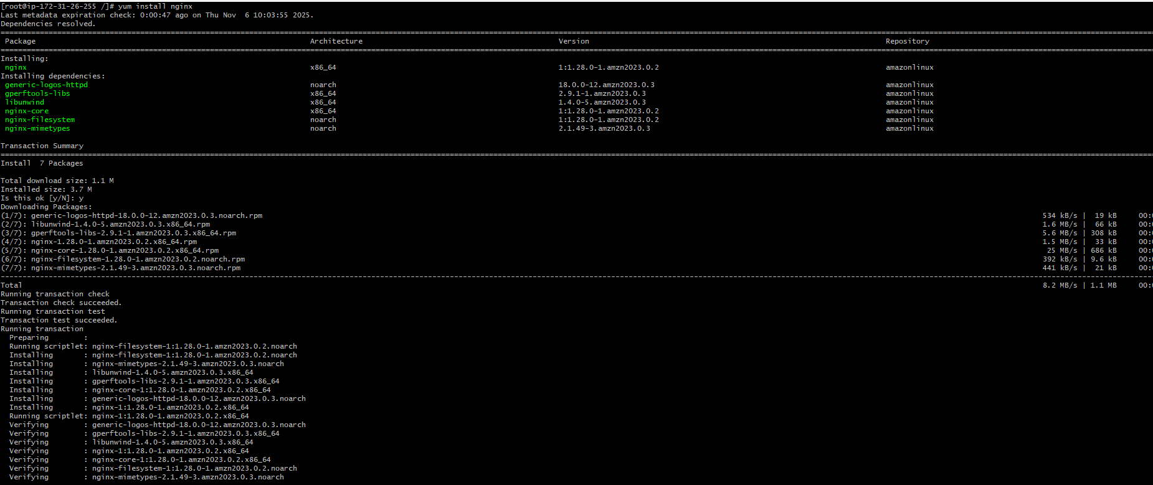
‘Once it get installed run the command to start the nginx (systemctl start nginx) and check the status with the help of command (systemctl status nginx) 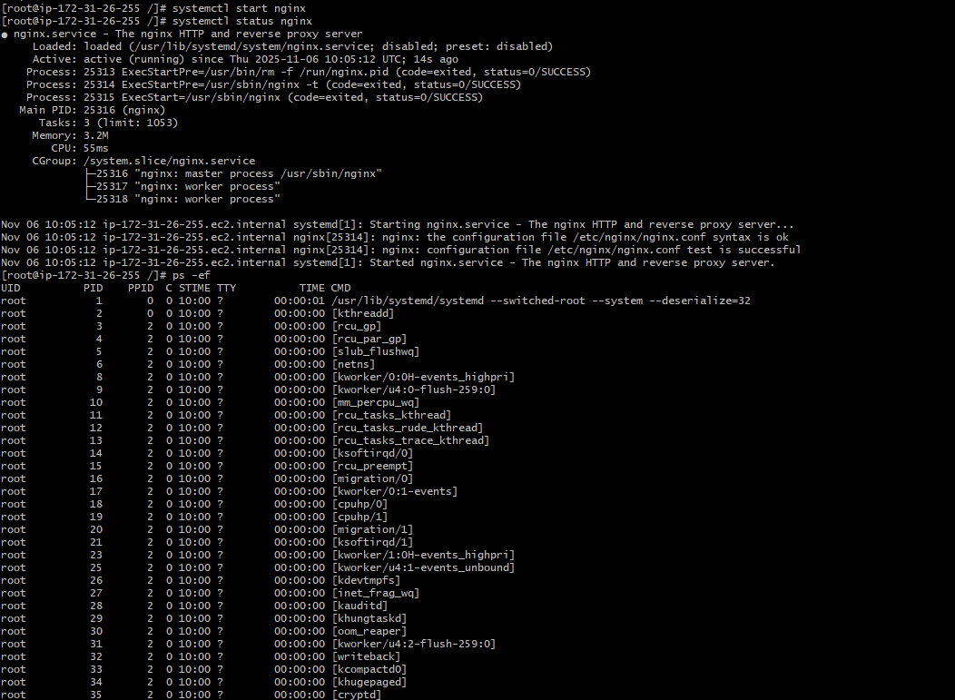
‘Then check on the browser with the help of publicip :portno
‘Then change the port no by typing cd /etc/ngnix and there is a file nginx.confg edit the file with vi and replace 80 to 81 and save the file restart the process with the help of (systemctl restart nginx) check the browser with public ip with new port no 81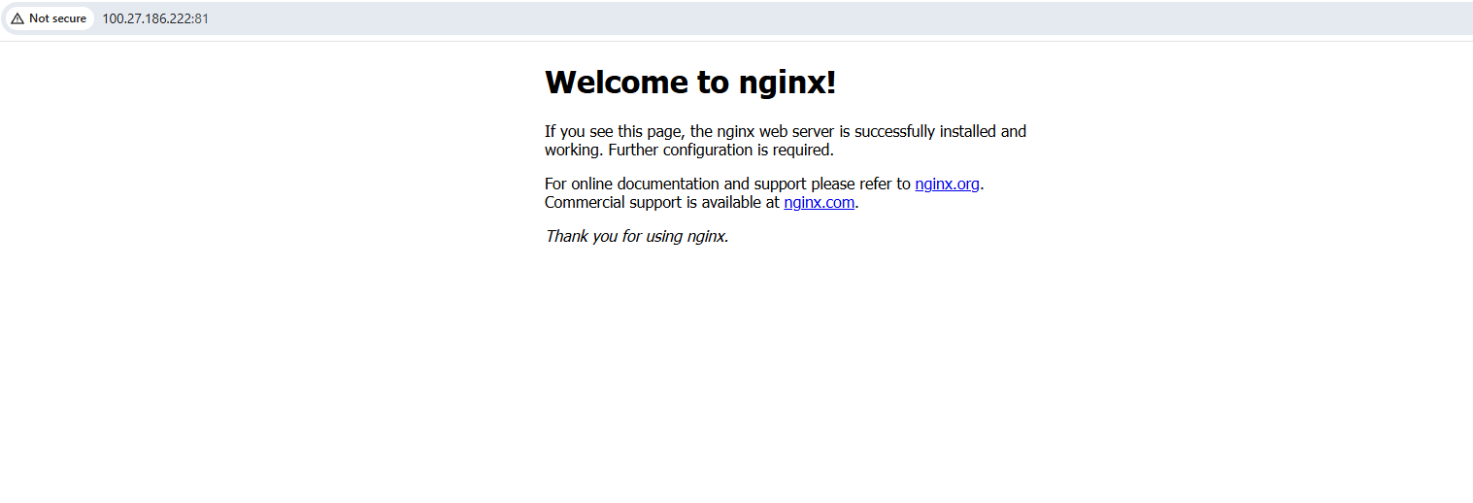

2: Deploy a sample index.html file on nginx.
- Ans: first need to check the index file while using command of (find / -name index.html)
and then check the path and use the command vi /usr/share/nginx/html/index.html
once it got edit save the file by using the command of :wq! 
3: Install Apache and run Apache on port number 82
Ans: First need to install the apache by using command of sudo yum install httpd -y 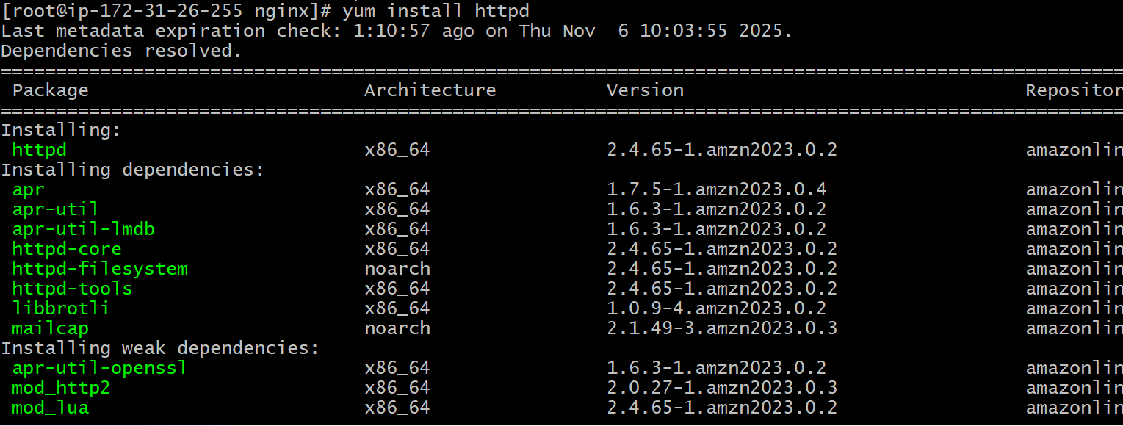
Once it got install use the command to start systemctl start httpd and check the status and go for the path cd /etc/httpd and need to edit for the port no by using command of vi httpd.conf change the listen port id and save 

4: Deploy a sample index.html file on Apache.
Ans: first find the index.html file by using ( find /-name index.html )
once you find the path edit the index file by using vi path and make the change and save it


5: Install Apache tomcat on port number 8082
Ans: first need to install the tomcat by using command of yum install tomcat incase you find error check on your browser and copy the link move to (cd opt) and use the command of wget paste link and once it get downloaded check through ls and extract the file by using (tar xvf filename)
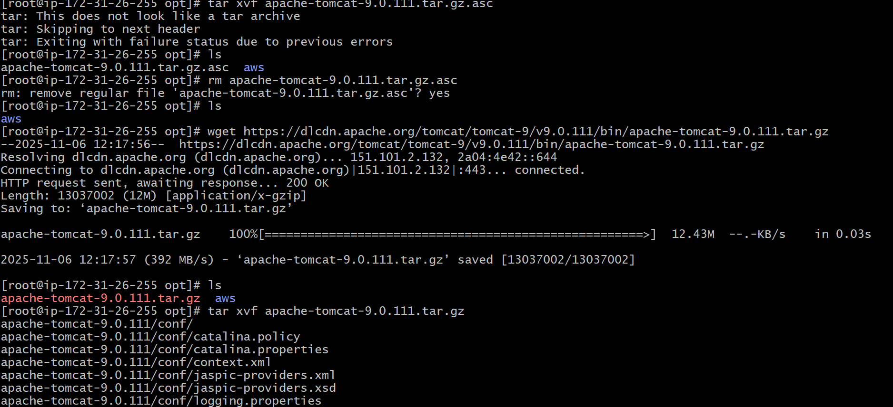
Once it xtracted use the command to enter the file cd file name. to able to start tomcat use command of (cd bin) and do ls check the list and to start the tomcat use the command of (bash startup.sh)or(./startup.sh) then need to vi server.xml change the port in connecter 8082 and save it showdown the file and startup again check in browser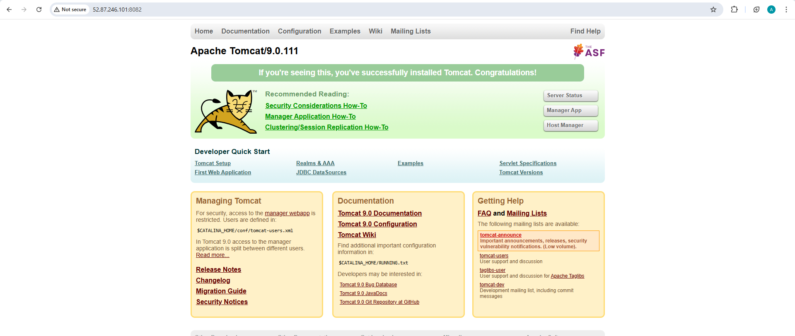

6. Deploy a sample app on webapps
Ans: first dowenload the sample file in in wabapps and run the command of ll sample is been created and check browser with public ip :8082/sample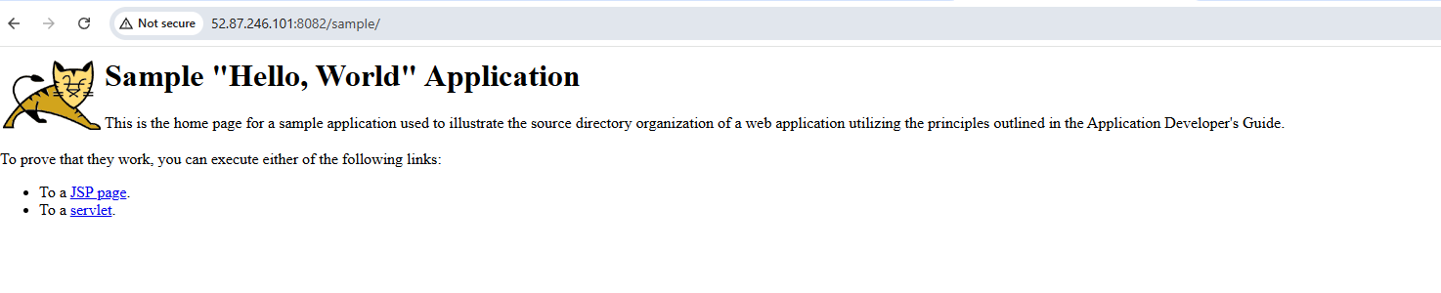
7: Create a tomcat.service file for tomcat.
Ans: first need to create tmcat.service file once it got created entre the data and save the file need to setup the instrucation create a user for the file and use the command (systemctl daemon-reload) to reload the file and then (systemctl start tomcat) then check (systemctl status tomcat) 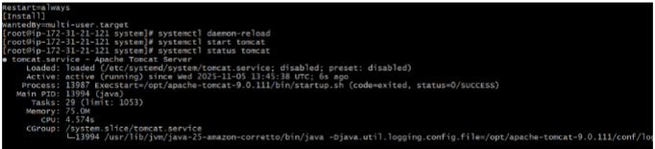

8: Configure HA Proxy server
Ans : first launch instance server 1 and need connect through ssh access 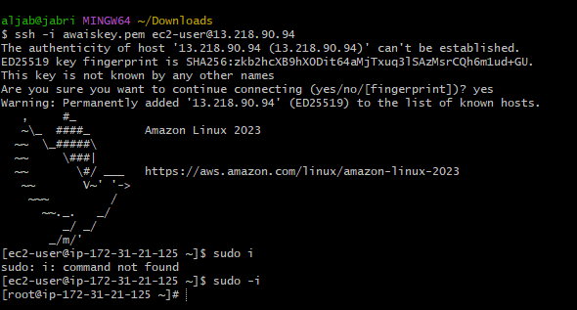
And then need to entre the command of (vi /etc/host) and entre your ha-proxy server pblic ip under the file and enter load_balancer and save the file once it got completed check through ping load_balancer -c 4it shows successfull 
Then run the command (systemctl start httpd)to start apace and check the status (systemctl status httpd) 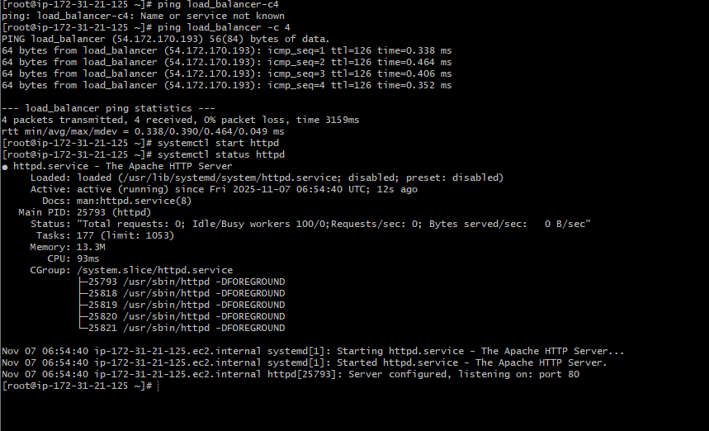
Need to check in browser through public ip and portno ‘80’ 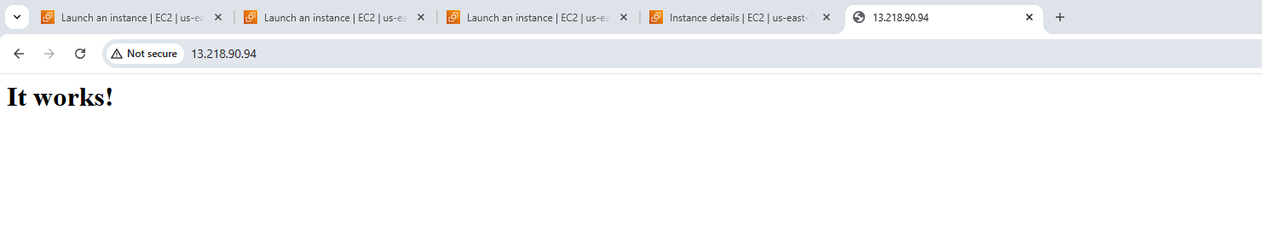
Server-2 Steps:
First need to connect server with the help of ssh -I privatekey.pem ec2-user@public ip
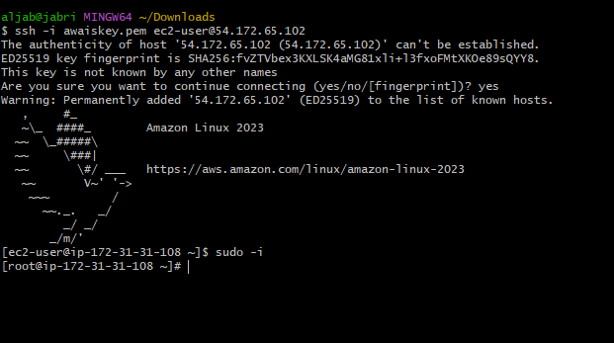
Then use the command to update (sudo yum update)and then install ngnix by using command of (yum install ngnix )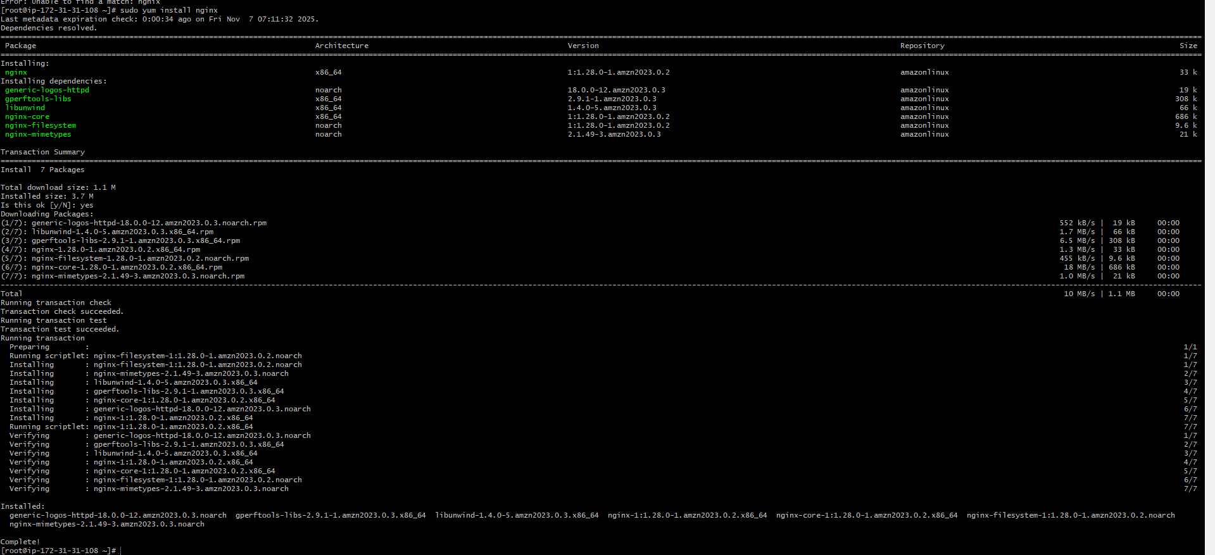
Then use the command (vi /etc/hosts) and insert -I to able to edit entre the pblic ip of ha-proxy server and save the file check by using command of (ping load_balancer -c 4) 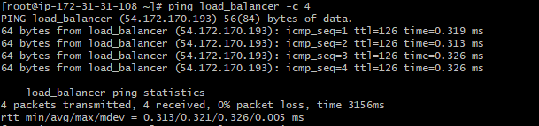
Then need to use the command to start nginx (systemctl start nginx) and check the status by using (systemctl status ngnix) 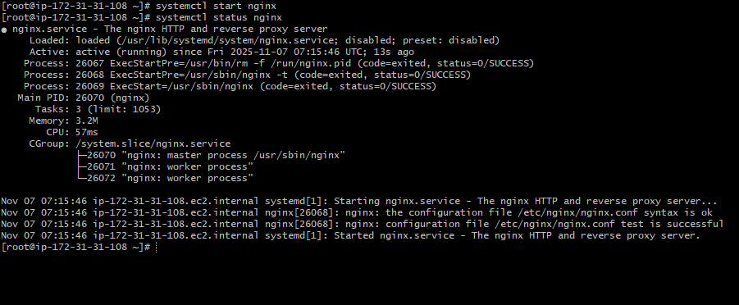
Now need to check in the browser with public and port no of 80 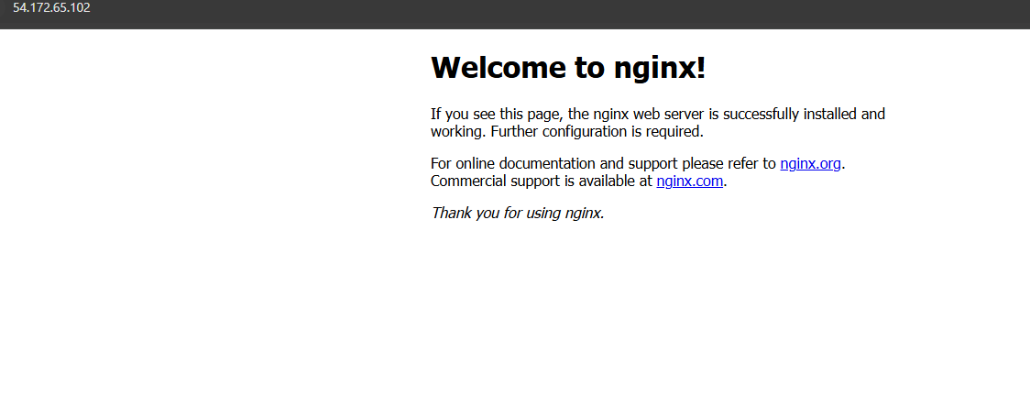
- HA-Proxy-Server Steps:
first need to connect with server with ssh using command of (ssh -i privatekey.pem ec2-user@public ip of the ha-proxy server) then sudo -i for root and use command yum update 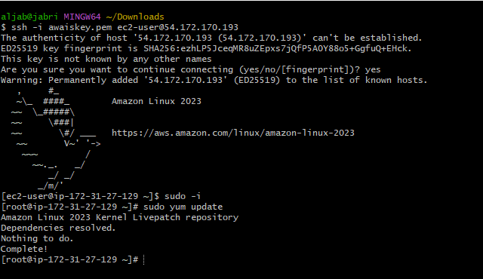
Then need to install haproxy by using command of (yum install haproxy -y) 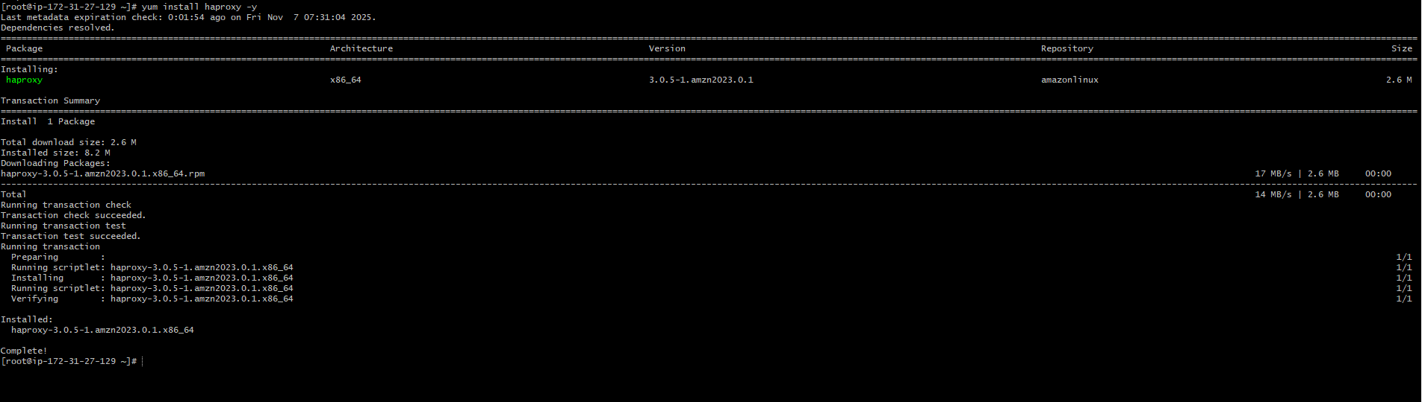
Then use command (vi /etc/hosts)and then enter server1 and server-2 pblic ip and save 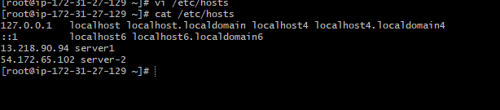
Then use command (vi /etc/haproxy/haproxy.cfg)
Add Server-1, Server-2 public IP’s 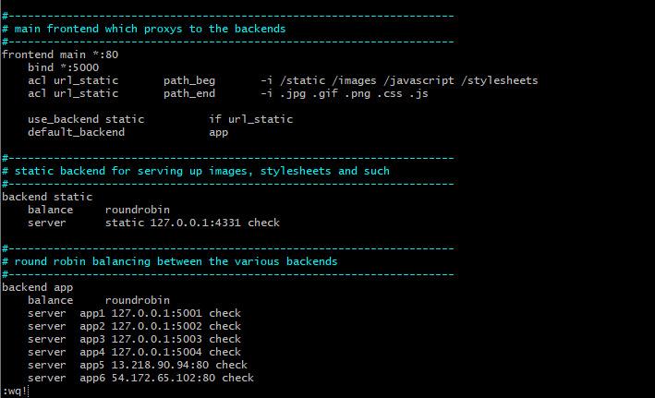
Then entre the command to start (systemctl start haproxy) and check the status (systemctl status haproxy) 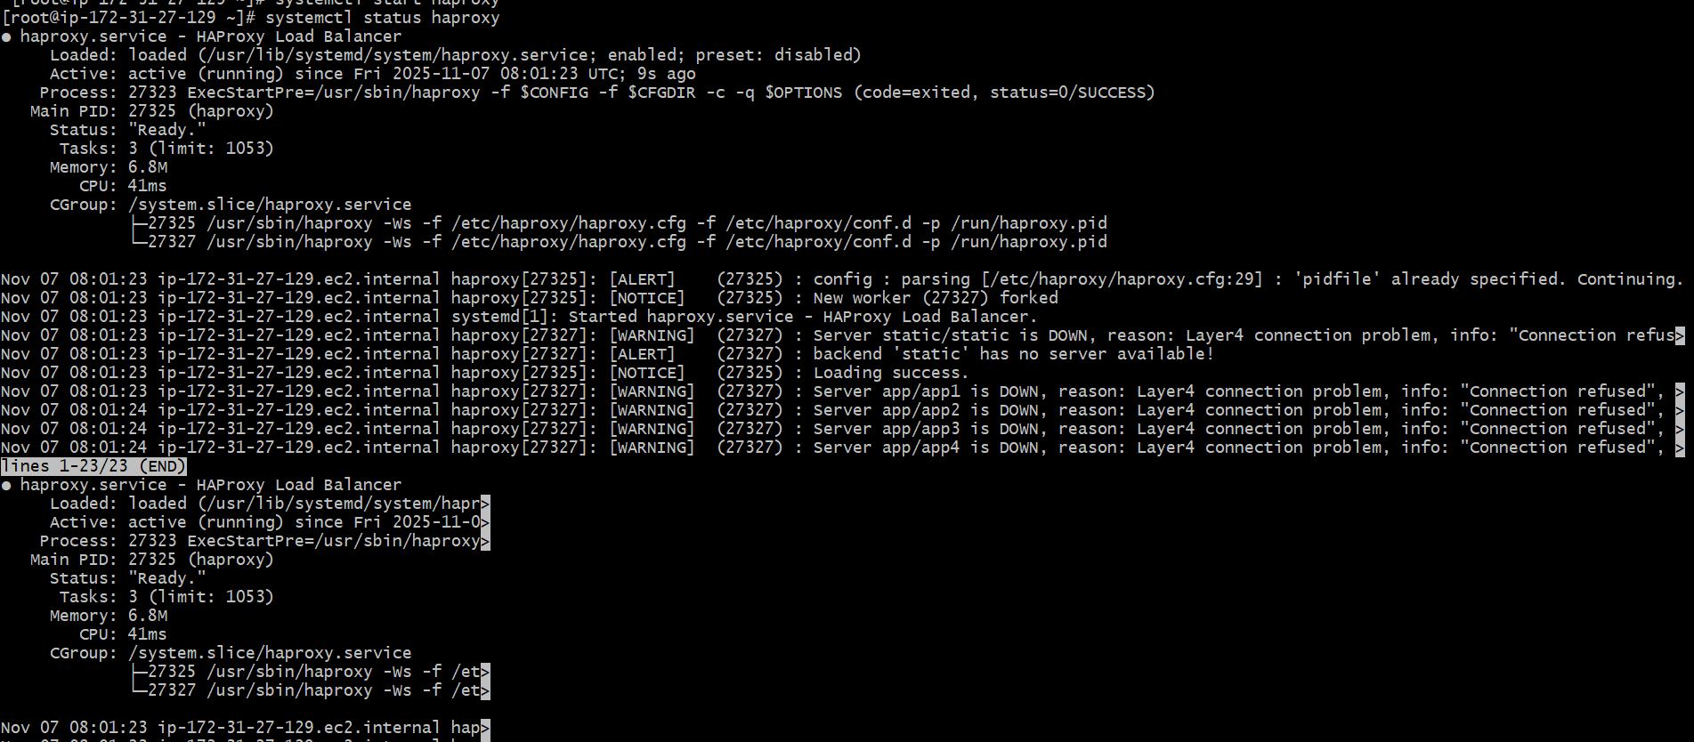
Then check in browser with public ip of ha-proxy server 